

# The Concentration of 39K and 41K by Balanced Ion Migration in a Counterflowing Electrolyte

Author(s): A. Keith Brewer, S. L. Madorsky and J. W. Westhaver

Source: *Science,* New Series, Vol. 104, No. 2694 (Aug. 16, 1946), pp. 156-157 Published by: American Association for the Advancement of Science Stable URL: <http://www.jstor.org/stable/1675532>

Accessed: 29-03-2017 21:28 UTC

### JSTOR is a not-for-profit service that helps scholars, researchers, and students discover, use, and build upon a wide range of content in a trusted digital archive. We use information technology and tools to increase productivity and facilitate new forms of scholarship. For more information about [JSTOR, please contact support@jstor.org.](mailto:support@jstor.org)

Your use of the JSTOR archive indicates your acceptance of the Terms & Conditions of Use, available at <http://about.jstor.org/terms>

*American Association for the Advancement of Science* is collaborating with JSTOR to digitize, preserve and extend access to *Science*

This content downloaded from 134.197.214.19 on Wed, 29 Mar 2017 21:28:07 UTC [All use subject to http://about.jstor.org/terms](http://about.jstor.org/terms)

156 SCIENCE Vol. 104, No. 2694

CONCLUSIONS

The behavioral development of the loggerhead tur­ tle in the egg consists of an initial mass-type C-move­ ment, the appearance of local response integrated with this pattern, and finally, elaborations of patterns of behavior subsequently adjustive in the terrestrial and aquatic environment of the animal.

The occurrence of a mass C-movement as a primary functional pattern of behavior i especially significant, since it establishes more firmly the role of mass move­ ment in the development of response. The observa­ tions show that these initial, generalized movements occur in an animal which, within a very short time, is incapable of displaying mass trunk activity.

Observations show that behavioral maturation and integration in the turtle are not related·to embryonic practice or repetition of respo se, but rather that they appear to occur as an outcome of physiological differ­ entiation and specialization of more generalized move­ ments in the maturation process.

Very generally, results indicate that in the growing ioggerhead the specific local movements as well as adaptive coordinations of response are ontogenetically organized with reference to more primary and gen­ eralized patterns of behavior which constitute a matrix for subsequent evolution of response.

**The Concentration of 39K and 41K by Balanced Ion Migration in a Coun­ terflowing ElectroIyte**1

1. KEITH BREWER 2 and S. L. M.ADORSKY

#### National Bureau of Standards, W ashinqton, D. C.

**J. W.** WESTHAVER

zero. Under this condition the faster-moving 89 K+ ions will make headway against the electrolyte stream toward the cathode compartment, while the slower­ moving 41 K+ ions will be carried back toward the anode compartment.

Tiselius *(4)* has described a method based on a mass fl.ow, which he designated as a "compensation movement" for the separation of proteins by electro­ phoretic migration. The separation takes place be­ tween a series of boundaries set up by the various proteins and is conducted at 4° C. to minimize con­ vection currents in the solution. The experimental arrangement of Tiselius cannot be utilized for the concentration of isotopes, however, since the difference in mobility of the ions is small compared to the proc­ esses giving rise to remixing.

In the separation of electrolytic ions, where the

transport can be looked upon as a small forward drift superimposed on kinetic agitation, it is necessary to reduce the rate of remixing in the electrolyte to a point below the rate of separation. Also, to obtain appreciable concentrations a multiple-stage process must be employed. Both these requirements have been met in the present experiments by carrying on the electrolysis in a fine-grained packing of uniform porosity. The packing not only reduces remixing to a minimum but acts as a fractionation column operat­ ing under total reflux. Packings have been made of sand, glass wooi, cotton, glass beads, etc.

During the initial stage of the operation, the molar isotope transport equals the gain in concentration of the faster-moving isotope in the cathode compartment and is given by

ITxtx (e-1) N1N2 VcxC

F = 1000.

#### U.S. Patent Office, Washington, **D.** C.

(R,

R, -R. ss

+ 1) moles

(1)

+ 1) (R. K

It has long been suspected that isobpic ions in solu­ tion might differ in their migration velocities *(3).* The negative results obtained by Kendall *(2)* in the elec­ trolysis of **Li+** and Cl- ions through agar-agar dis­ pelled most of the hope for an isotope effect of this type. Recently, however, a counter-current ion trans­ port method has been developed which not only estab­ lishes the reality of this effect but also makes possible the continuous concentration of both **39 K +** and **41 K +** isotopes.

The basic principle of operation of the method rests in an imposed fl.ow of electrolyte through the cell at a rate sufficient to reduce the net transport of **K+** ions to '

1 A statement describing briefly the method and some early experimental results of isotope separation was submitted to the director of the National Bureau of Standards on 13 June 1941. Until recently it has been withheld from publication because of wartime security restrictions.

2 At present with the U. S. Navy Department.

where I+= positive ion current before superimposing the counterflow, in amperes; t = time in seconds; **N11 N**2 = mole fractions of **39 K** and **41 K ,** respectively; **R** = isotope abundance ratio, **NiJN2 ;** Ve= cathode vol­ ume, in milliliters; C = normality of electrolyte; and F = Faraday constant: 96,500 coulombs/mole.

The separation coefficient, e, can be calculated directly from equation (1). The physical significance of E is _that it represents the ratio of the forward velocity of the faster to the slower isotopic ion. The minimum length of column required to obtain a sepa­ ration of e is the length of one theoretical unit, h. The over-all separation factor for a column of n theo­ retical units is given by

St=oo= (N1/N2)c/(NiJN2)a=En (2) where c and a refer to the cathode and anode compart­ ments.

This content downloaded from 134.197.214.19 on Wed, 29 Mar 2017 21:28:07 UTC All use subject to <http://about.jstor.org/tenns>

16 August 1946

SCIENCE 157

A lower limit for h can be computed for a capillary tube and can be approximated for a packing by as­ suming that the pores behave as equivalent capillaries. In the ideal case of a capillary with isothermal cross­ section, h is limited by the fact that the liquid velocity profile is parabolic while· the ion velocity profile is

ride. **A** solution of hydrochloric acid was admitted to the cathode compartment at such a rate that the solu­ tion turned from acid to alkaline midway between drops, the rate of feed being controlled by manually adjusted capillary droppers. The cathode volume was 11 ml., and the electrolysis current was 0.5 amp. with a potential drop between the electrodes of 93

HCI **(1, 29.28)** KOH (1•30.72)

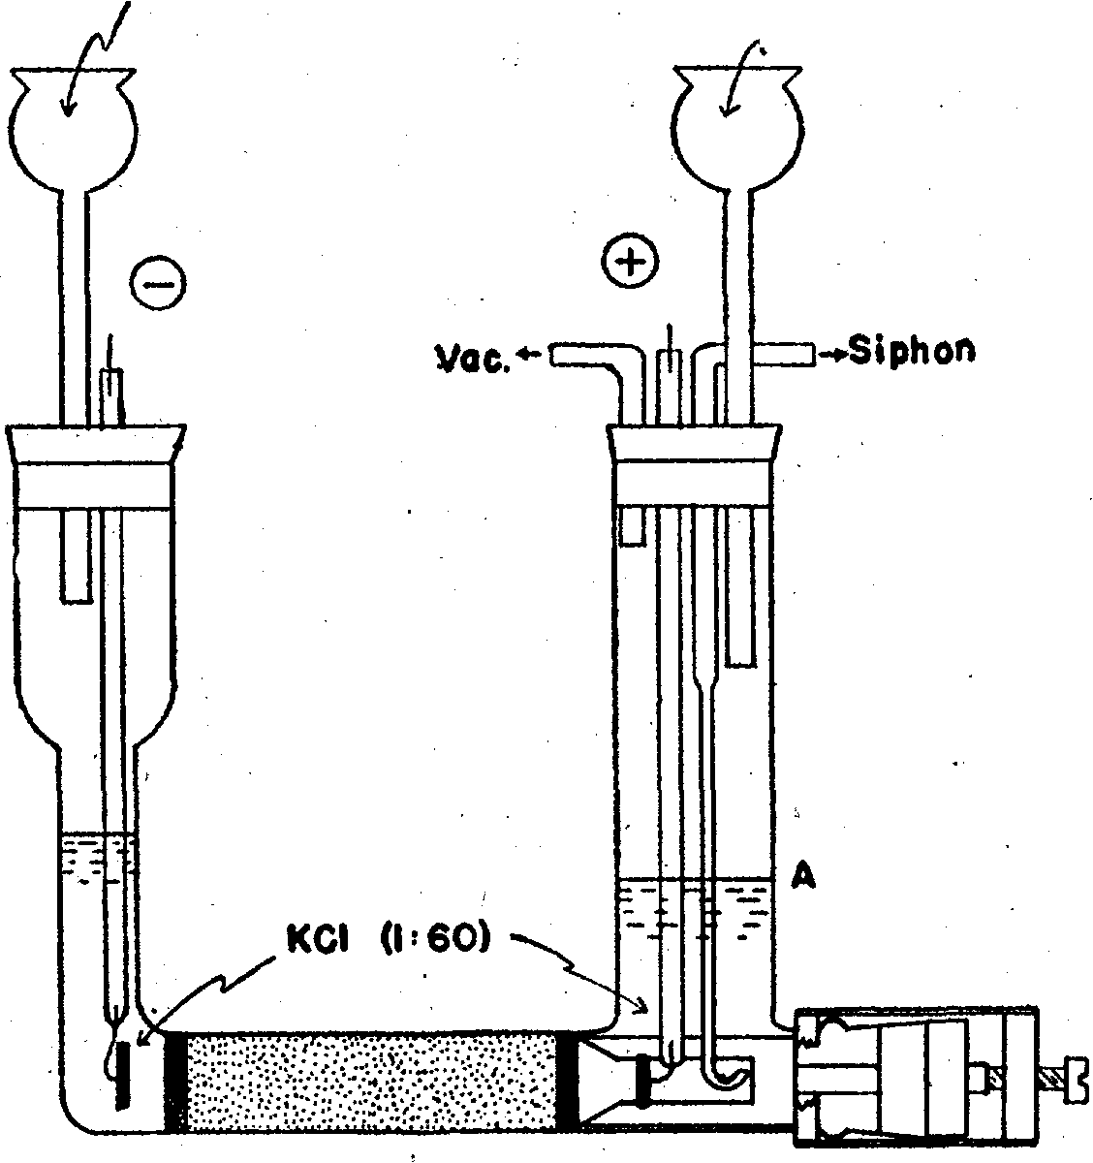

*I*

FIG. l

**Vac.**

**KCI (1•60)**

### volts. The abundance ratios, 3 9 K / 41K, were measured with a mass spectrometer by the method· previously described (1).

A large number of experiments have been per­ formed to determine the separation efficiency under various conditions. The maximum value observed for i; is 1.0039, while the average value is 1.0022. Changes of more than 50 per cent in the relative concentration of **39 K** or 41K have been obtained.

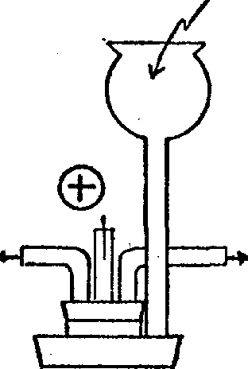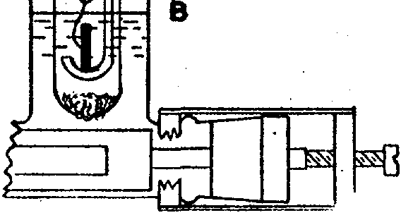

**Siphon**

**References**

1. BREWER, A. KErrH. *J. Amer. chem. Soc.,* 1936, **58,** 370 ;

*Ind. eng. Chem.,* 1938, **30,** 893.

2. KENDALL, JAMES. *Science,* 1928, **67,** 163.

1. LINDEMANN, F. A. *Proc. roy. Soc.,* 1921, **99A,** 103.
2. TISELIUS, A. *.Trans. Faraday Soc.,* 1937, **33,** 524.

### uniform; it is also limited by back diffusion. The relationship is expressed by

h = (1/48) V,r2 o/ D + D/Va cm. (3) where Va= mean liquid velocity, in centimeters/sec­ ond; ro = radius of bore, in centimeters; and D = coeffi­ cient of stagnant diffusion, in square centimeters/sec­ ond. ,

Equation (3) shows that approximately 100 theo­ retical units per centimeter should be obtained in a 00-mesh granular packing. This cannot be realized in practice, however, because of remixing due to non­ uniformity of pore size, temperature variation, convec­ tion, and inconstancies in operating conditions.

One of the many types of cells tested is illustrated in Fig. 1.

The results obtained. in a typical run are given in Table **1.** In this experiment a 100-mesh sand pack-

TABLE **1**

Hours

## Determination of Total Body Water and Solids With Isotopes1

FRANCIS D. MOORE

#### Harvard Medical School, Massachusetts General Hospital, Boston, Massachusetts

Measurement of total body water has in the past been accomplished on post-mortem material by desic­ cation techniques (*12).* In animals it ·has been pos­ sible to measure total body water by the dilution of urea or. sulfanilamide *(10),* but neither of these methods is particularly well adapted to such mea­ surements in the human patient. The ideal method with which to measure a body fluid compartment is by the dilution of a "tracer" for one of the normal constituents of that compartment. For the measure­ ment of total· body water the theoretically ideal tracer would be an isotope of hydrogen or oxygen.

In the past, techniques for the measurement of other body fluid compartments have been developed. Most of these methods depend, in one form or an­

0

41

131

161

209

281

329

377

449

14.20

15.30

16.4

18.2

19.2

20.5

21.1

22.2

24.0

(Natural potassium)

other, on the tracer principle and the basic formula:

**V** - C, V1

. 2 - C2

### where **C1** and V1 represent, respectively, the concen­ tration and volume of the tracer · before dilution in

ing, 10 .cm. in length and 1.4 cm. in diameter was used. The anode compartment was of the B type, which is to be preferred since it does not necessitate a precise metering of the solution of potassium chlo-

the subject, and C2 and V2, concentration and vol­ ume after injection. Such methods have yielded measurements of plasma volume (3), red cell volume

1 The work• described in this paper was done under a con­ tract, recommended by the Committee on Medical Research, between the Office of Scientific Research and Development

*:·* ml Harvard University.

This content downloaded from 134.197.214.19 on Wed, 29 Mar 2017 21:28:07 UTC All use subject to <http://aboutJstor.org/terms>